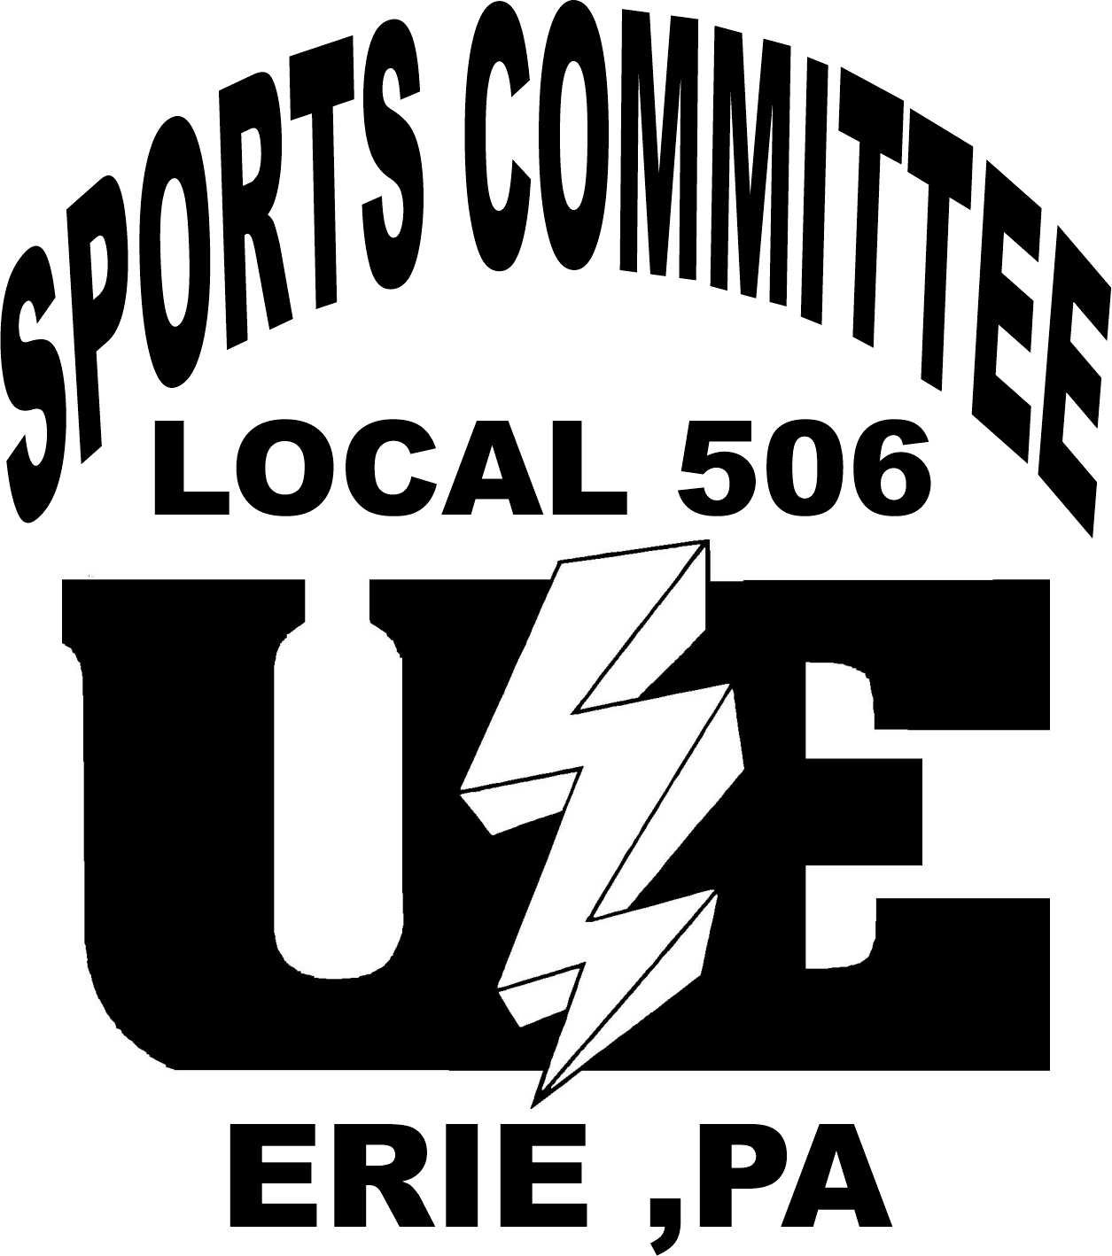
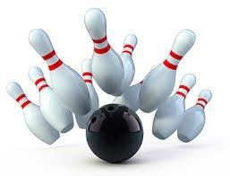
17th ANNUAL HOMETOWN
HEROES BOWLING TOURNAMENT
EASTWAY LANES
SUNDAY, FEBRUARY 24, 2019
1:00 pm

APPLICATION FORM

TOURNAMENT RULES

- Event shall consist of three (3) games bowled on one (1) pair of lanes assigned by the
Tournament Director and all decisions by the Tournament Director are final.

- This is a singles event. Prizes will be awarded to the highest game and highest series
bowled by both men and women. There will be no duplication of awards.

- This is a fun-filled community event for our sponsors and friends of all ages.

- Please note your bowling fee is not considered a donation to the Erie VA Medical Center and the fee only covers the cost of bowling.

♦ ENTRY FEE: $15 each ♦ 5 people on a lane ♦ Limited to the first 200 paid entries

Deadline to PREREGISTER is Friday, February 15, 2019. Availability is limited the day of the event. Junior bowlers are welcome. Check in begins at Noon. There will also be auctions. Please note that 100% of proceeds will benefit Erie VA Medical Center.

Mail ENTRIES to: UE Local 506; 3923 Main Street; Erie, PA 16511. You may also drop off your entry to the Union Hall at the above address any weekday from 8:00 a.m. – 4:00 p.m. Make entry fee check payable to: UE 506 Sports Committee. Questions concerning the tournament, please contact Matt McCracken at 814-440-0218 or Dave Chadwell at 814-881-7300.

If you would like donate for this fundraising event, please make checks payable to: Erie VAMC and mail to VAMC Voluntary Office, 135 East 38th Street, Erie, PA 16504. Please respond to this letter by Friday, February 15, 2019, if you would like to be recognized as a sponsor.
-----------------------------------------------------------------------------------------------------------------------------------------------------------------------------------------------------------------------
ENTRY FORM – TEAM LINE UP (please print) ♦ ENTRY FEE: $15 each ♦

FIRST AND LAST NAME PHONE NO.

1. ____________________________________________ _________________

2. ____________________________________________ _________________

3. ____________________________________________ _________________

4. ____________________________________________ _________________

5. ____________________________________________ _________________

Five bowlers not required. Singles or Pairs accepted

THANK YOU 2018 SPONSORS AND DONORS!

U.E. Local 506 Sports Committee, Erie, PA | Sunflower Club, Erie, PA
American Legion Post 571, Wesleyville, PA | Veterans of the Vietnam Ware Inc. Post 52, Meadville, PA
American Legion Post 237, Inc., Union City, PA | VFW Post 1835 Auxiliary, Franklin, PA
American Legion Post 742, Fairview, PA | VFW Post 1835, Franklin, PA
American Legion Post 285, Waterford, PA | VFW Post 4789, North East, PA
American Legion Post 135, Warren, PA | VFW Post 740, Edinboro, PA
American Legion Post 365, Corry, PA | VFW Post 943, Ashtabula, OH
American Legion Post 108, Bradford, PA | VFW Post 2006, Meadville, PA
American Legion Post 381, Cambridge Springs, PA | VFW Post 264, Corry, PA
American Legion Post 771, Erie, PA | VFW Post 470, Erie, PA
American Legion Auxiliary Post 571, Wesleyville, PA | VFW Post 4789, Northeast, PA
American Legion Post 105, North East, PA | VFW Post 7599, Transfer, PA
American Legion Post 658, Youngsville, PA | VFW Post 6166, Hermitage, PA
American Legion Post 700, Warren, OH | Texas Roadhouse, Erie, PA
American Legion Post 758, Sugar Grove, PA | Hosses, Erie, PA
American Legion Post 615, Conneautville, PA | The BrewErie, Erie, PA
American Legion Post 103, St. Mary's, PA | Peg Lucas, Erie, PA
AMVETS Auxiliary Post 50, Sugar Grove, PA | Calamari's Restaurant, Erie, PA
AMVETS Post 113, Tionesta, PA | Cinemark, Erie, PA
BPO Elks, Lodge 329, Kane, PA | Pat Grove, Erie, PA
BPO Elks, Lodge 437, St. Mary's, PA | Carol & Chuck Goodman, Erie, PA
BPO Elks, Lodge 110, Franklin, PA | Karen O'Neal, VAMC
BPO Elks Lodge 769, Corry, PA | Bill McCracken, Waterford, PA
Cascade Park Club, Erie, PA | DAVA, Unit 47, Jamestown, NY
Corry Central Labor Club, Corry, PA | Victoria Hoover, Union City, PA
DAV Chapter 73, Erie, PA | Victoria Hoover, Union City, PA
Disabled American Veterans Auxiliary Unit 73, Erie, PA | Roger Zaczyk, Union City, PA
Dusckas Funeral Home, Erie, PA | Faye Jarmolowicz, Erie, PA
Employee Community Service Fund of GE, Erie PA | Evelyn Toskin, Erie, PA
Foresters Beneficial Association, Erie, PA | Victoria Hoover, Union City, PA
I.B.E.W. Local 56, Erie, PA | Jack Denny, Erie, PA
International Assoc of Fire Fighters Local 293, Erie, PA | Nadean Sitter, Erie, PA
J. Amato & Son, Meadville, PA | Hooks Early Intervention Services, Melissa Hooks, Erie, PA
Keystone Paralyzed Veterans of America, Pittsburgh, PA | Karen Rubay, Wattsburg, PA
Kindle Heating and Cooling, Erie, PA | Eastway Lanes, Nancy Warren, Erie, PA
NABET-CWA Local 28, Erie, PA | Lincoln Electric, Erie, PA
Siebenbuerger Club, Erie, PA | Potratz Floral Shop, Erie, PA
Slovak National Club, Erie, PA | Dave Chadwell, Erie, PA
Society of Holy Trinity Group #240, Erie, PA | Sons of American Legion Post 571, Wesleyville, PA

