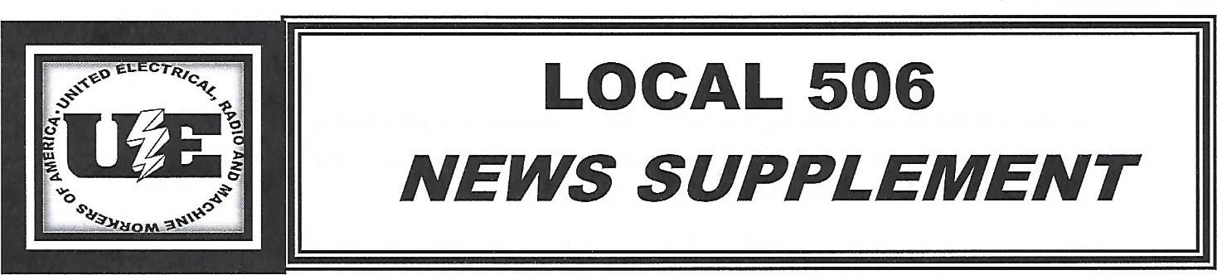
April 5, 2019
Wabtec Negotiations Update
Representatives of UE Local 506, UE Local 618 and the UE National Union met with Wabtec’s negotiating committee during the week of April 1 - 4. The two sides continued to exchange proposals - both non-economic and economic, including wages, job codes, job bidding, union representatives and stewards, paid time off, working hours, holidays and temporary transfers. Since the end of the strike/lockout we have met ten times, but the two sides still remain far apart on the issues that caused the strike/lockout. Negotiations will resume the week of April 9 - 11.
When we resume negotiations, we will have 56 days left to reach an agreement before the 90-day interim agreement expires on June 3rd. We have made it clear throughout negotiations that our members will not accept:
- Two tier wages
- Mandatory overtime
- Changes in overtime pay
- Changes to the work week
- Reductions in paid time off
- Weakening seniority rights
- Temporary workers
- A new grievance and arbitration procedure
- Undermining union representation

Wabtec knew what it was getting when it bought/merged with GE Transportation – a business which has consistently posted double-digit profit margins. With the elimination of the defined benefit pension and retiree health insurance, Wabtec is already realizing a $16 million annual savings. Wabtec doesn’t need any additional concessions from our members to make the Erie facility more “competitive.” Our members’ skills and experience in locomotive building are second to none and they should be compensated as such.

For more info: “Like” UE Local 506 on Facebook or visit our website: uelocal506.com
Printed by UE 506

