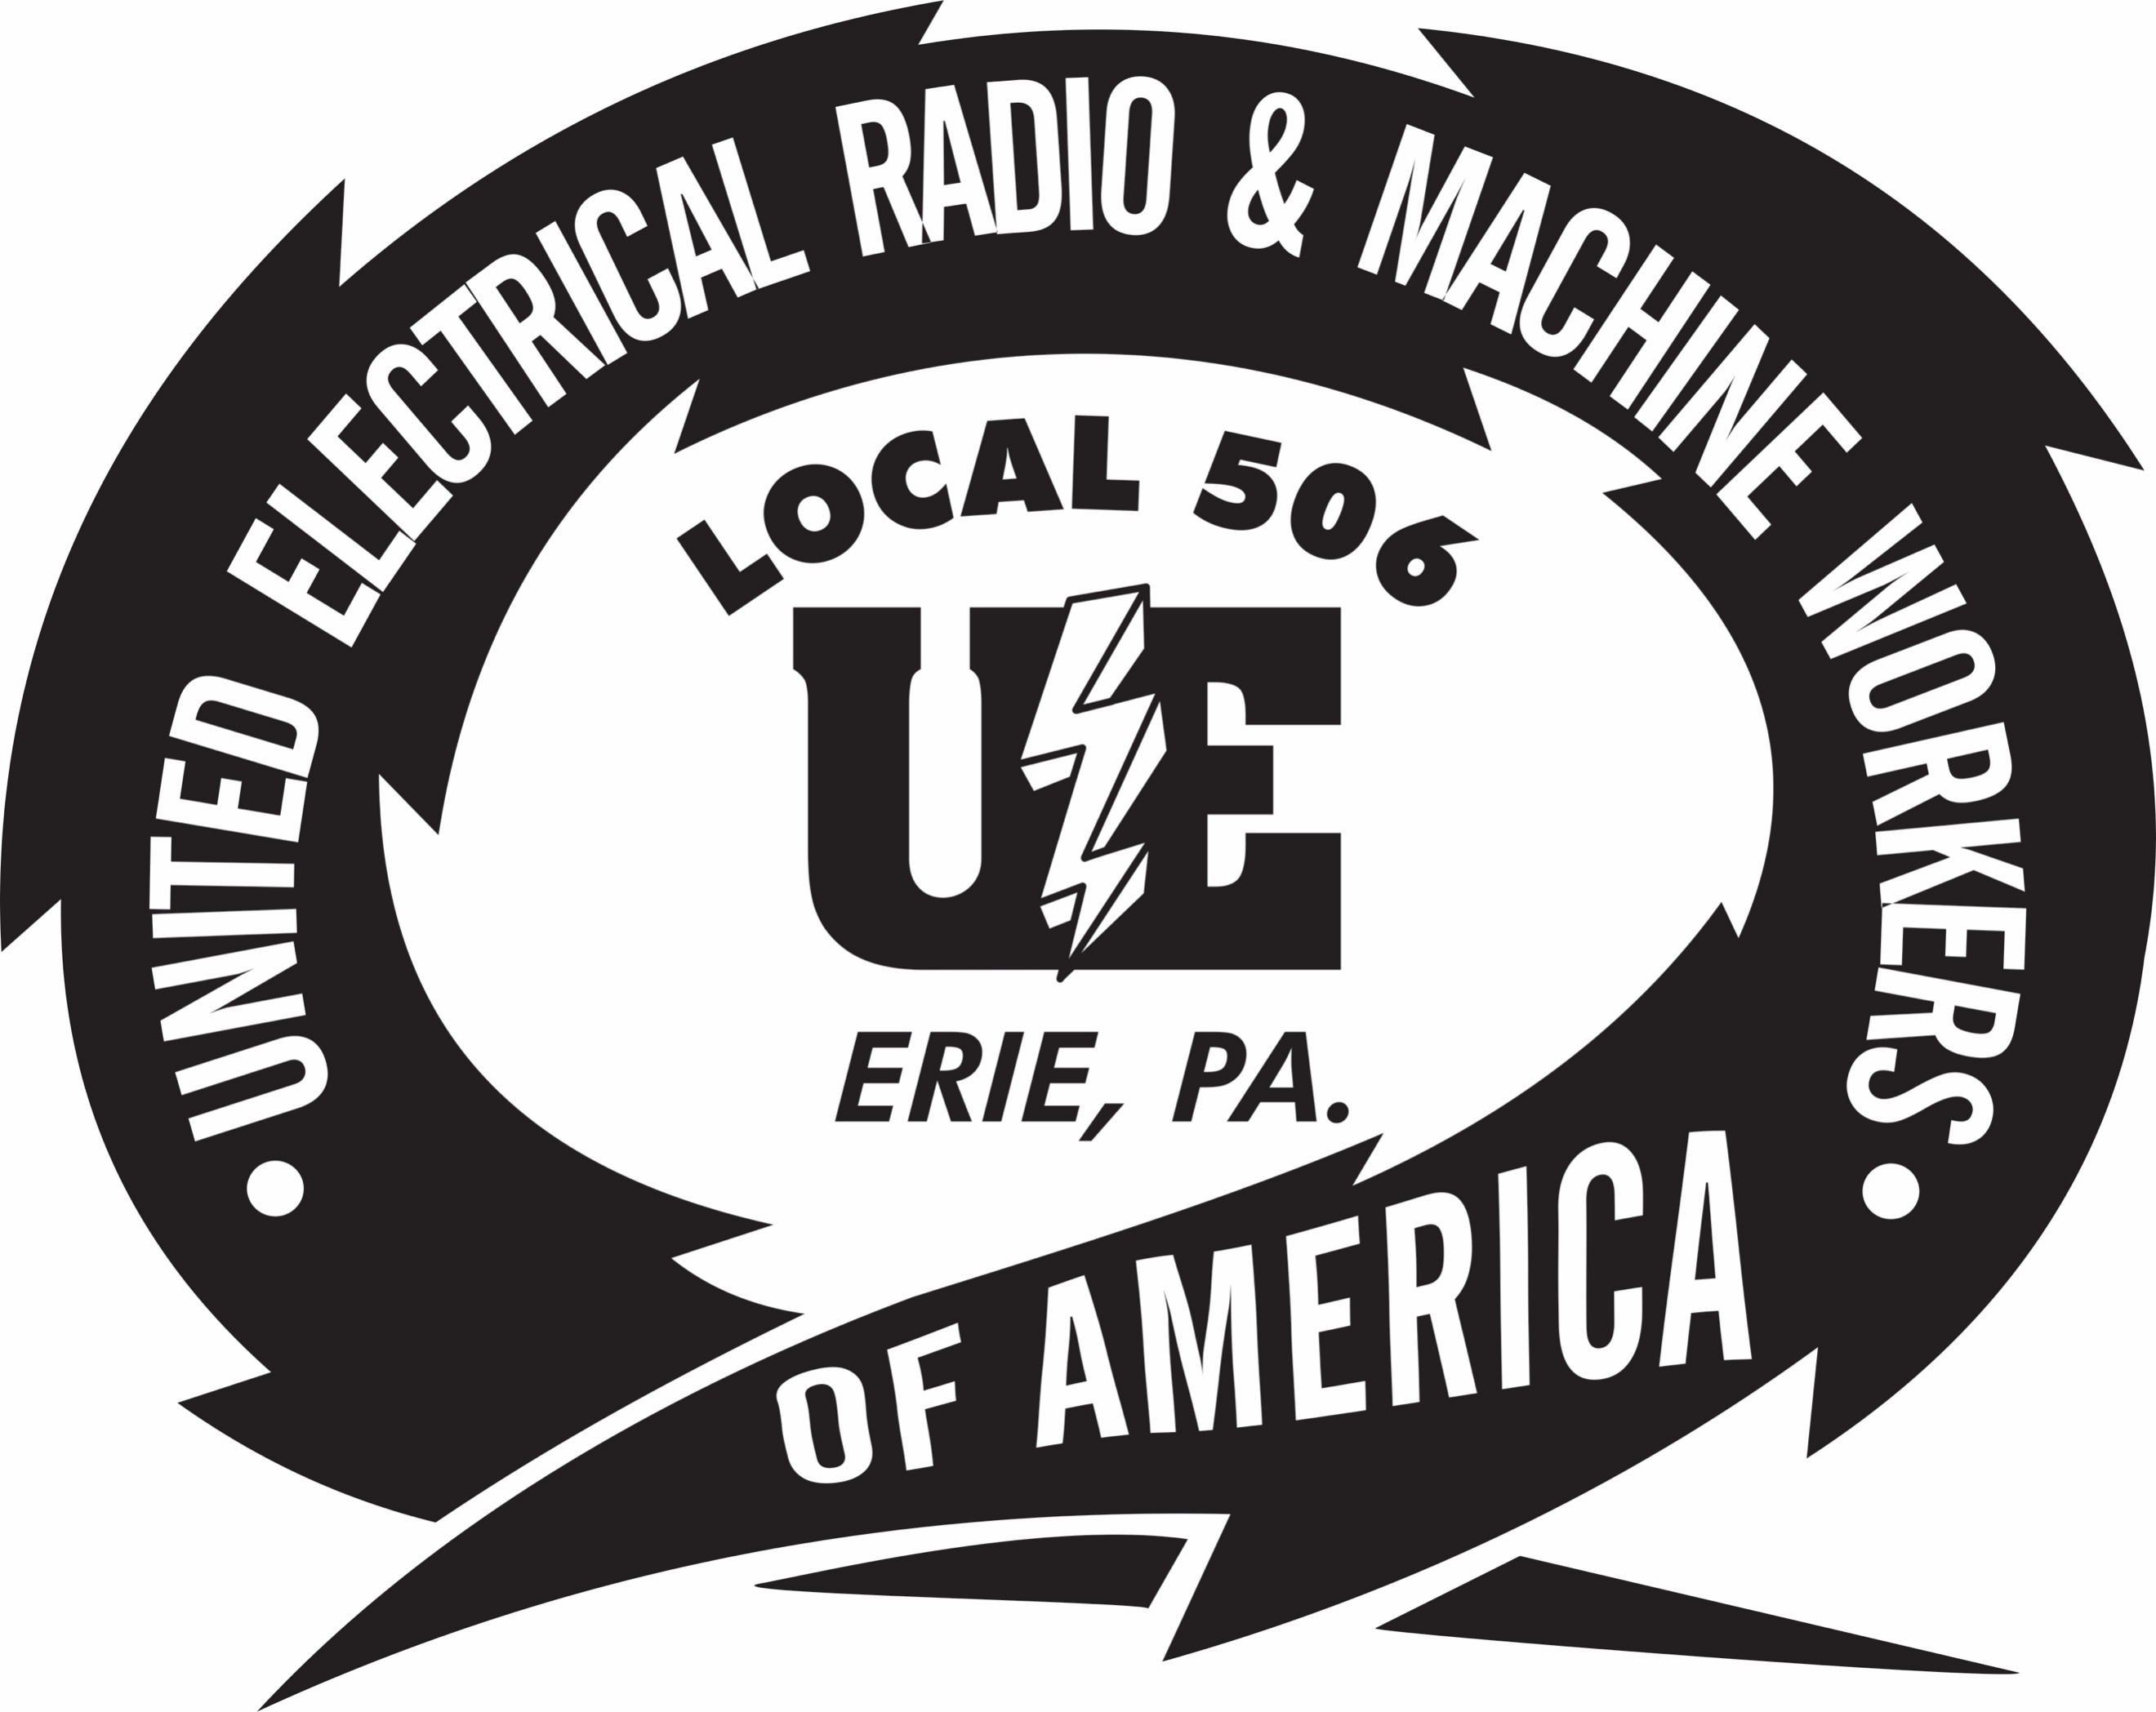

BULLETIN
11/8/2019

As Wabtec initiates permanent layoffs, we will do our best to communicate with you and ensure every member affected receives the benefits that they are entitled to. The disappointing news that Wabtec is moving forward with permanent layoffs, is coupled with a troubling decision to not continue temporary lack of works in this situation.

We continue to urge the Company to consider each employee as they issue layoffs. This approach has served affected families in the past, as well as labor/management relations. Here are some of the obstacles we are facing:

- These layoffs are permanent, as opposed to temporary.
- Many of the affected employees may not be eligible for unemployment compensation which could impact their TRA entitlement
- We have been working with the State to identify those individuals based on service in affected jobs, but because the company has not provided the State with 2019 second-quarter earnings, our efforts have been rendered useless. Without these reports, it's impossible to verify and prepare for those who will be laid off and not eligible for unemployment compensation benefits.
- The Union has raised these concerns with the company repeatedly, and continue to urge them to take employees and their families into consideration before they are impacted.

In the meantime, the Union has scheduled a benefits session with the Pennsylvania Department of Labor and Industry Rapid Response meeting for November 18, 2019, at 9 am. Pennsylvania CareerLink, PA Unemployment and other agencies will provide benefits rights interviews, information on trade benefits and the Affordable Care Act (ACA). Representatives will provide members with information about all benefits available to them. Benefit Rights Interviews (BRI’s) will be conducted during this meeting and are required to be eligible for Trade benefits.

