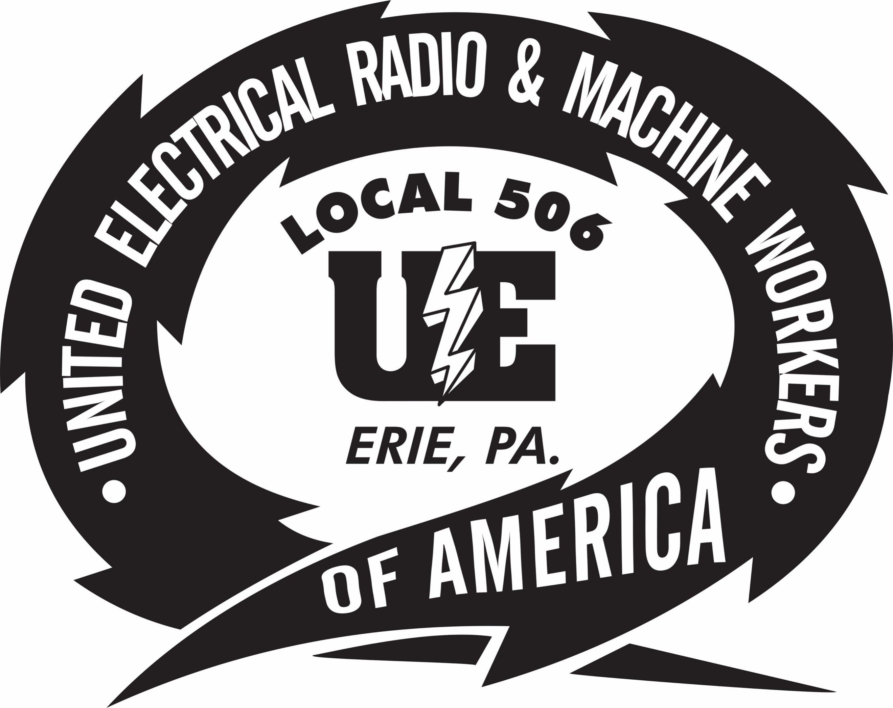

BULLETIN
11/19/2019
LAYOFF BENEFITS RIGHTS INTERVIEWS
When: November 25, 2019, 9:00AM
December 9, 2019, 9:00 AM

Where: UE Local 506
3923 Main Street

The Union has scheduled benefits meetings with Pennsylvania Department of Labor and Industry, Rapid Response for November 25, 2019, at 9 AM and December 9, 2019 at 9 AM. Pennsylvania CareerLink, PA Unemployment and other agencies will provide Benefits Rights Interviews (BRI’s) for trade benefits and very important information on the Affordable Care Act (ACA). Benefit Rights Interviews (BRI’s) will are required to be eligible for Trade Benefits. Members who missed the November 11th, meeting are encouraged to attend the November 25th, meeting. Spouses are welcome to attend these meetings.

Printed by UE Local 506 11/19/2019

