Skype set up
Before your meeting on June 4th at 1:30, make sure you have access to Skype (free download, or you can join via web)
You can join in on the meeting via a computer or by phone (computer or by Skype APP on smart phone would be best because will have an interactive section for your input and will be sharing a virtual PowerPoint.)
App is available for android or Apple -
Here is a basic Video on how to join a meeting Video - Basics to skype

Join a Skype for Business meeting with Skype Meetings App

(Skype for Business Web App)
Skype for Business Web App Skype Meetings App More... Less
If you don’t have the desktop version of Skype for Business, or don’t have a Skype for Business account, you can use Skype Meetings App or Skype for Business Web App to join a Skype for Business meeting from your browser.
Depending on how your computer is set up, you will use either Skype Meetings App or Skype for Business Web App. Below you will find steps on how it will look once you download the APP or program.
Skype Meetings App Skype for Business Web App

Join a meeting using Skype Meetings App
Here are the basic steps to join a Skype for Business meeting with Skype Meetings App.
- Open the meeting request in your email or calendar, and select Join Skype Meeting. (Depending on your version, you may see Join Online Meeting.)
- Follow your browser's instructions for installing Skype Meetings App. For example, in Internet Explorer, select Run when you see the alert at the bottom of the browser window.
- On the Skype Meetings App sign-in page, enter your name, and select Join.

Make sure our put your FULL NAME in the “enter your name box” this way you will get credit for attending the Trade BRI meeting.
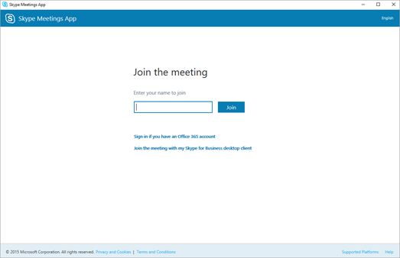

Join a meeting using Skype for Business Web App
Here are the basic steps to join a Skype for Business meeting with Skype for Business Web App.
- Open the meeting request in your email or calendar, and select Try Skype Web App.
- On the Skype for Business Web App sign-in page, enter your name, and select Join the meeting.
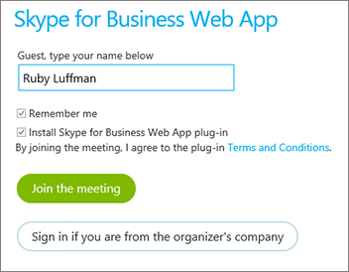
- Follow your browser's instructions for installing the Skype for Business Web App plug-in, which is required for audio, video, and screen sharing.
- Depending on the meeting options set by the organizer, you'll either join the meeting immediately, or be directed to the virtual lobby.
If you're in the lobby, the meeting organizer and other presenters are immediately notified that you're waiting.

See Also
Skype Meetings App help
Trouble installing the Skype Meetings App?

To join the meeting, once you download the program to your computer… do the following:
- At meeting time, open your Skype for Business email invitation, and then click Join online meeting in the email message.
- If this is the first time you are joining a meeting, your browser might ask you to download Skype Meetings App. Click Join with the Skype Meetings App (web).
- In the Skype Meetings AppWelcome screen that opens, type your name in the Enter your name text box, and then click Join.
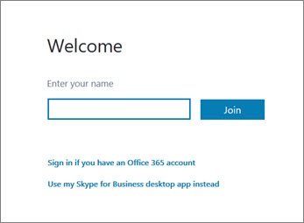
To send an instant message to meeting participants, do the following:
- Click the IM icon.
- At the bottom of the IM window, click the message input area, and begin typing.
Tip: You can format your message using the text formatting options, and add emoticons if you’d like to.
- Press Enter.
Note: Your IMs are received by all the meeting participants.

