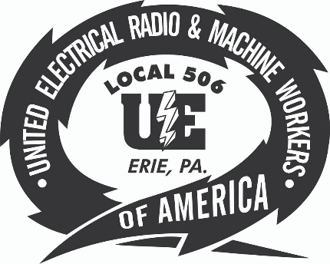
Protect the Right to Organize (PRO) Act

3/15/2021
WASHINGTON — Here's how area members of Congress voted on the PRO Act (HR 842) during the legislative week ending March 12.

HOUSE: Protecting Labor's Right to Organize: Voting 225-206, the House on March 9 passed a bill (HR 842) that would protect and expand employee rights to collectively bargain for better pay, benefits and working conditions. The bill would establish the right to organize as a civil right enforceable in federal court; prohibit the permanent replacement of striking workers; enable employees to file class-action lawsuits over working conditions; negate state right-to-work laws allowing non-union employees to benefit from negotiated contracts without paying union dues; make it difficult for employers to classify "gig economy" workers as independent contractors to prevent them from joining unions; and authorize fines of up to $50,000 per violation for employers who unlawfully interfere with organizing campaigns. A yes vote was to send the bill to the Senate. Rep. Mike Kelly, R-16th Dist.: No. Rep. Glenn Thompson, R-15th Dist.: No.

Despite Kelly and Thompson, the PRO Act passes the house, moves to the Senate
Although Congressmembers Kelly and Thompson voted against this important legislation the bill will be sent to the Senate. To ensure passage of the PRO Act we must demand our representatives vote in favor of the bill. You can help get the PRO Act passed by going to
https://actionnetwork.org/forms/pro-act and letting Senators Toomey and Casey know that you support the PRO Act. You can also call your Senators today at (202) 224-3121 and demand that they co-sponsor this important piece of legislation!

